**Integrating Jenkins With Github (Trigger Jenkins Jobs using Github Webhooks)**

**Pre-requisites:**

* Install Java
* Install Jenkins
* Github Account

**Gitgub Account:**

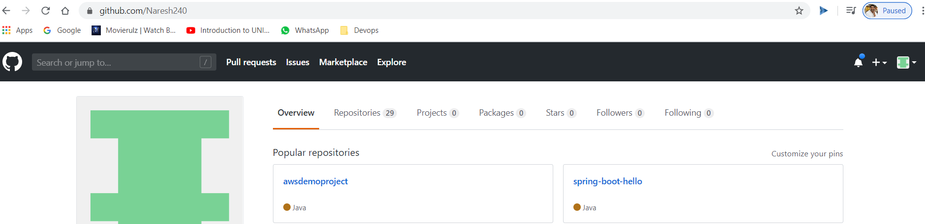

Open our Repository:

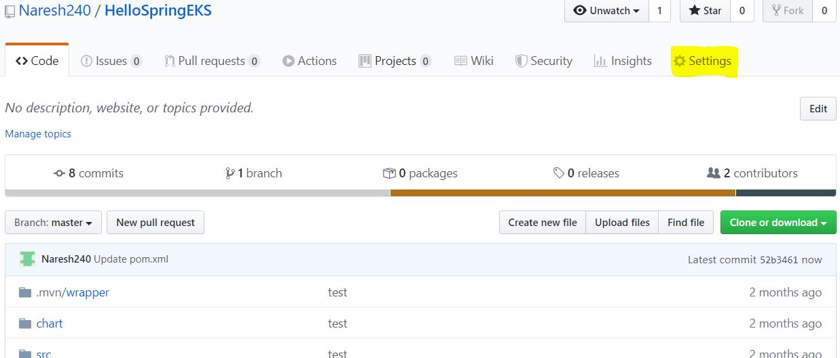

Click on settings

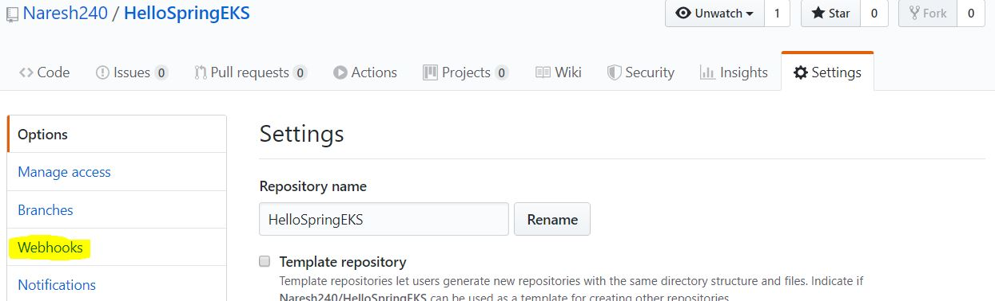

Click on Wehooks

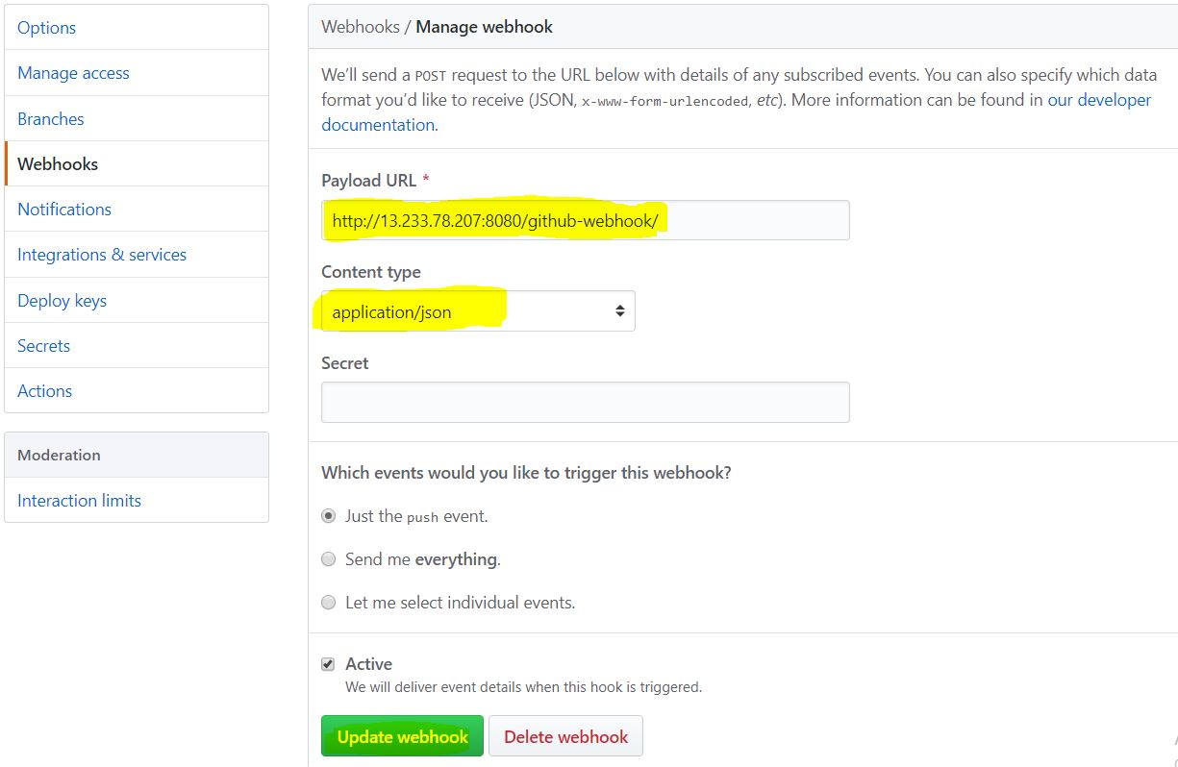

Give details as below:

Payload URL: <Jenkins-URL>/github-webhook/

Content type: application/json

Click on Update webhook

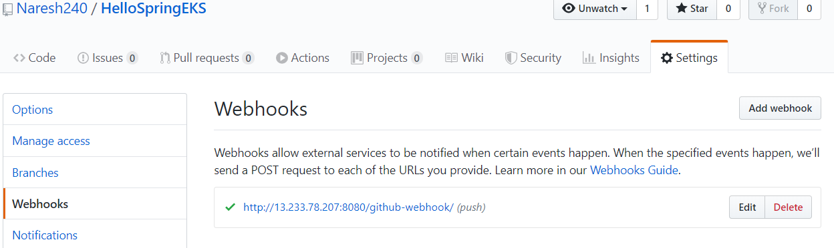

**Jenkins Server:**

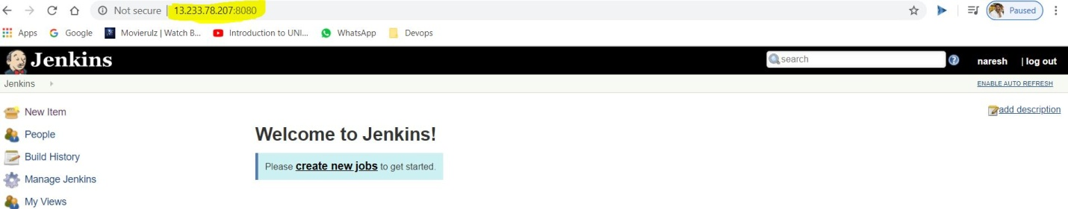

Click on New Item

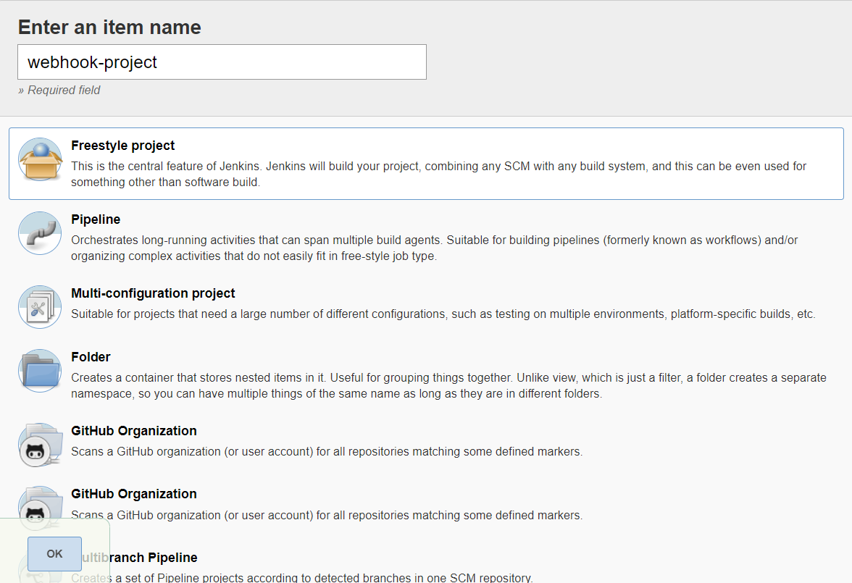

Enter an item name and select Freestyle project

Click on OK

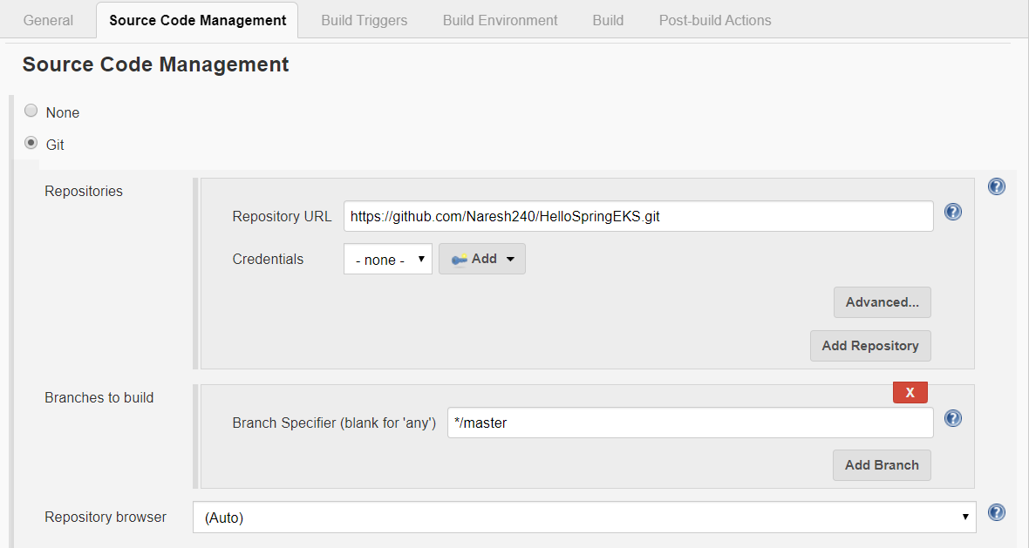

Give Repository URL

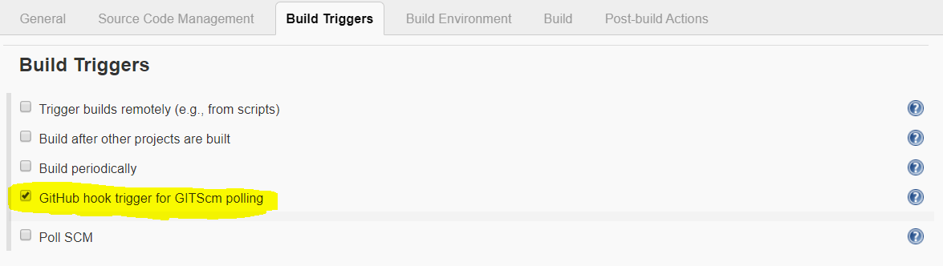

Select **GitHub hook trigger for GITScm polling**

Click on **OK**

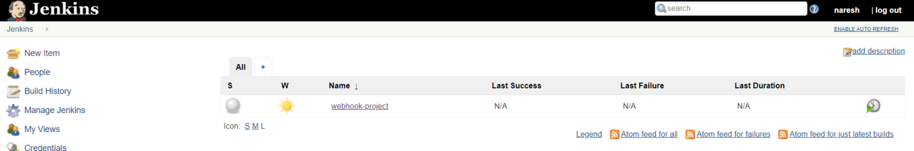

Now do some changes in **github**

Open Pom.xml and write something in comment and check Jenkins job whether Build done automatically or not

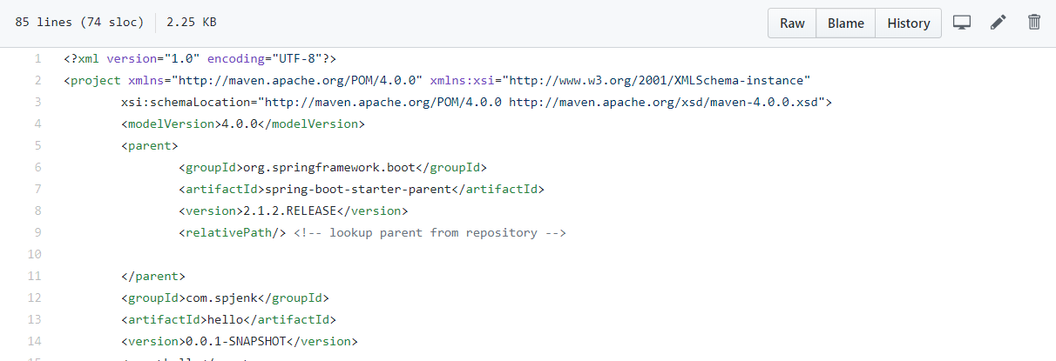

Now writing something here

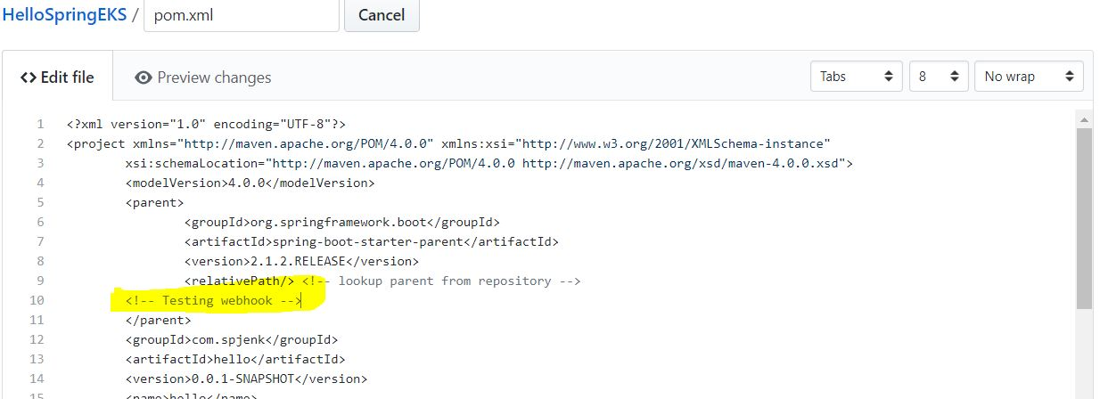

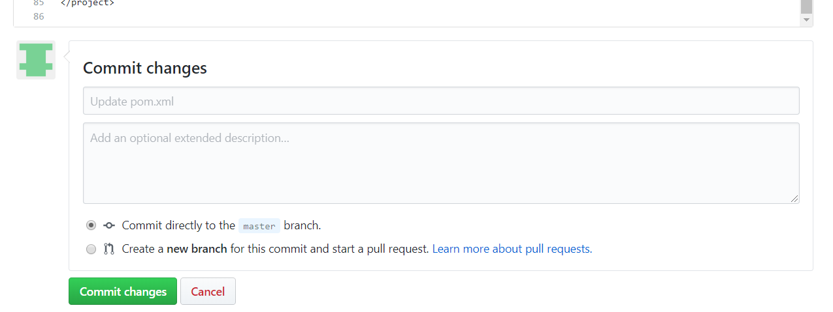

Click on Commit changes

Now check Jenkins UI whether job Build automatically or not

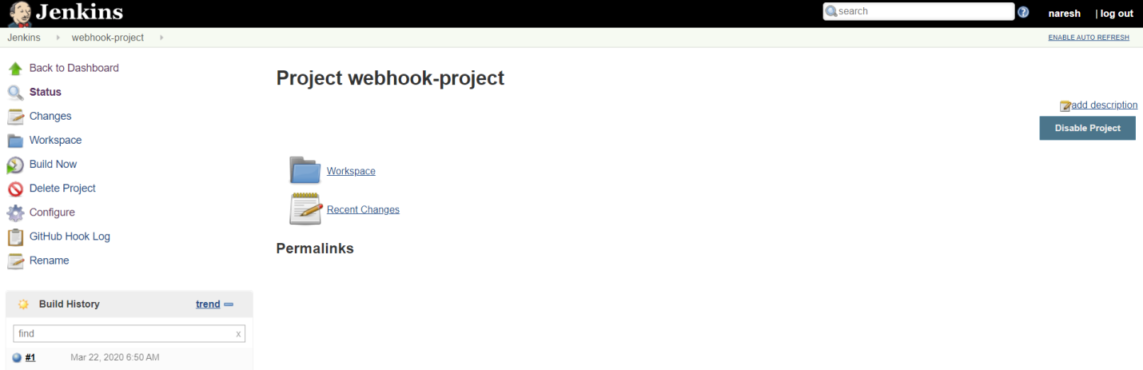

Build done automatically